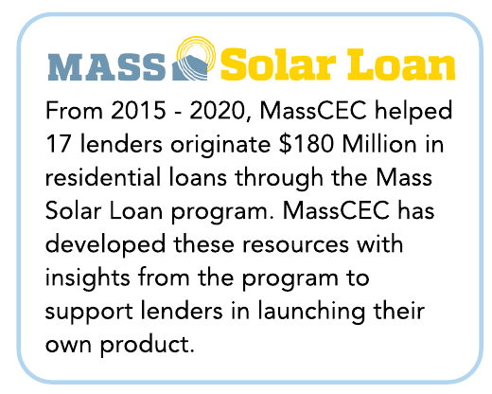
The application phase is the opportunity to collect key information and documentation about the project to ensure it meets any set project requirements, and ensure the project is designed and contracted before disbursing the initial funds. This application can also be an opportunity for the borrower and installer to sign to any specific product terms or conditions as applicable. For details on the information and documentation requested during Mass Solar Loan technical application please see our Installer Quick Start Guide and Program Manual (page 29-31).
Project information and documentation to consider collecting is detailed below – lenders are encouraged to build their own checklists from this information based on the level of detail they are seeking. Items detailed below were collected to verify and document the provided project information as part of Mass Solar Loan, a state-funded public program, and may not make sense for a lender offering their own loan product.

Project Information
- Basic Site Information: Customer Name, Site Address, Utility, Property Ownership Details
- Installer Information: Name, Contact Name, Address
- Residential/System Confirmations: Residential Rate Code, Roof/Ground Mount
- Equipment Information: Inverter Manufacturer / Model / Count, Panel Manufacturer / Model / Count, Energy Storage Manufacturer / Model / Count (If applicable)
- Array Information: (If seeking to receive specifics of system design or estimated production): Array Tilt, Azimuth, Shading for each array, Overall System TSRF (Total Solar Resource Fraction)
- Costs: Total System Cost, Amount being financed

Project Documentation
- Signed Summary: A signed document containing the relevant project information noted above. This is an opportunity for parties (consider both installer and customer) to confirm the accuracy of provided information and agree to appropriate terms such as any technical requirements, warranties, or other requirements of the product.
- Aerial Photo: With the project site identified a photo can help confirm site address is correct and that array information matches visible property layout.
- Customer Electric Bill: Can be used to confirm utility, site address, residential rate code.
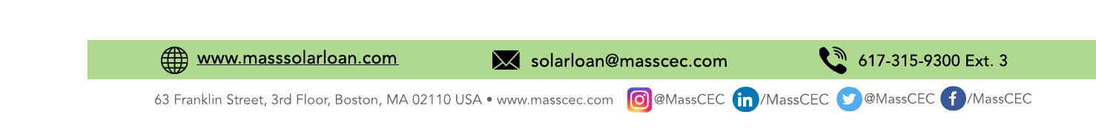
- Shading Analysis: If setting TSRF or requirements based on estimated system production, a shading analysis can be required as documentation of those values. Even if not collecting shading analyses consider requesting that the install confirm a shading analysis was completed and provided to customer to help ensure the customer has an accurate understanding of their estimated production.
09132021

- Unusual Ownership: For projects with unusual ownership structures such as condominiums you may consider requesting documentation of how system costs/benefits, including tax credit, energy savings and other incentives will flow to borrower and other entities.
- Copy of Contract: Under Mass Solar Loan a contract was only collected at completion, however requiring a contract at application can help ensure you have documentation of project specifics and that the project is in fact contracted to move forward.

Mid Project Elements
Lenders considering 3 disbursements may want to consider potential trigger requirements for a mid-project disbursement. Potential documentation for a disbursement that lines up with the start of construction include:
- Customer confirmation that construction has commenced or is scheduled.
- A copy of the Electrical or Building Permit.
- Invoices or other documentation of the equipment order.

Completion Elements
The completion phase should focus on collecting final project information and documentation, and confirming the system is installed and operational prior to making the last loan disbursement. For details on the information and documentation requested during Mass Solar Loan project completion please see our Installer Quick Start Guide and Program Manual (page 29-31).
Project Information and Documentation to consider collecting are detailed below – Lenders are encouraged to build their own checklists from this information based on the level of detail they are seeking. Note as public program, items detailed below that were collected erred on collecting more info to verify the provided project info and may not make sense for a lender offering their own loan product.

Confirm Project Information
- Confirm Equipment Information: Inverter Manufacturer / Model / Count, Panel Manufacturer / Model / Count, Energy Storage Manufacturer / Model / Count (If applicable)
- Confirm Array Information: (If seeking to receive specifics of system design or estimated production): Array Tilt, Azimuth, Shading for each array, Overall System TSRF (Total Solar Resource Fraction)
- Confirm Costs: Total System Cost, Amount being financed

Project Completion Documentation
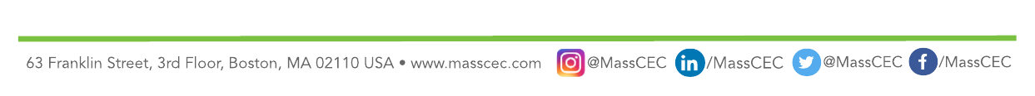
- Authorization to Interconnect / Permission to Operate from Utility: A required document for all solar PV and potentially the most important document to require. Each utility may refer to this document by different names, but the key is that this is the approval from the utility for the system to interconnected and turned on, ensuring that the system is operational. This approval intrinsically includes approval from the local electrical/building officials as part of the application for most utilities.
- System Photo(s): Photos of the installed system – can be used to confirm panel counts/locations. Can be matched with aerial photo to confirm photos are of the correct project.
- Copy of Contract: If a copy of the contract was provided at application this could also just be a confirmation the original contract remains accurate, the contract can be used to confirm the final project cost aligns with the initial cost and loan amount or if the second disbursement needs to be adjusted
- Signed Summary: A signed document containing confirming the final project information or any adjustments as made and documented in the completion materials. It is recommended that this document be signed by both the customer and installer to ensure all parties are comfortable the system is operational and has been completed relative to both parties understanding of the contract scope.
- Additional Documentation: Depending on the nature of any project changes relative to application, you may also consider an updated shading analysis or additional documents for unique ownership situations.

